**Roman Pot Upgrade for STAR**

Elke-Caroline Aschenauer, Wlodek Guryn, Jeong-Hun Lee and Phil Pile

This document has two parts: comparison between physics reach of Phase II\* and the full PHASE-II of Roman Pots at the STAR detector and the cost estimate of implementation of that phase at STAR.

We would like to note that both Phase-II\* and Phase-II address the recommendation by the PAC in their 2011 report to propose a solution, which allows parasitic or concurrent running with the rest of the RHIC program [1]. This requires relocating existing Roman Pots to DX-D0 region (Phase-II\*).

1. **Summary of physics gain from Phase-II\* to Phase-II**

Roman Pot in STAR Phase-I, Phase-II\* (aka Phase-IIa) and Phase-II:

* **Current configuration (Phase-I)** two horizontal (at 55.5m) and two vertical (at 58.5m) Roman Pots (RPs) each in outgoing Yellow and Blue beam (Detector: 75x45mm2)
* **Phase-II\*:** reconfiguration of Phase-I detectors. Two vertical RP each at ~15.2m and at ~17.3m (Detector: Phase-I detector)
* **Phase-II**: two vertical +one horizontal (at ~15.2m) and two vertical and one horizontal (at ~17.3m) RPs each (new Si-Detector: 100x70mm2)

**Searches for a gluonic bound state in central exclusive diffraction (Double Pomeron Exchange) in pp**

One of the challenges in identifying a glueball state unambiguously lies in difficulties of isolating a glueball state from the conventional meson state that shares the same quantum numbers. A kinematic ``filter'' for enhancing glueball candidates in DPE process is the so-called dpT filter. A possible dynamics behind the phenomenon is that small momentum transfer processes are expected to enhance *gg* kinematic configurations since the gluons can flow directly into the final state in the process. (See Fig. 1)

**Phase-II setup will enhance the acceptance at high-t significantly** (see Fig 2) from having an additional plane in horizontal direction. The detectors in horizontal/bending plane cover protons with large momentum loss (large-*t*) as shown in Fig. 3. Additionally **more complete coverage in azimuthal angle** with the additional horizontal plane will introduce **less bias and corrections in spin-parity analysis** of the centrally produced system.



Figure 1 The coupling of the exchange particles into the hadronic final state for gluon exchange (left) and for quark exchange (right).

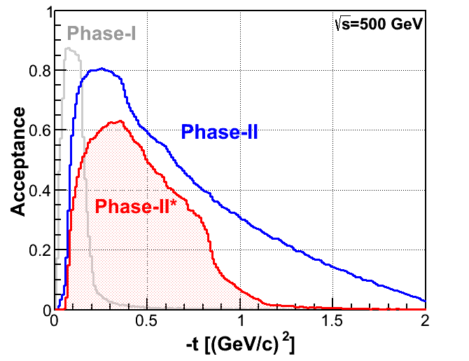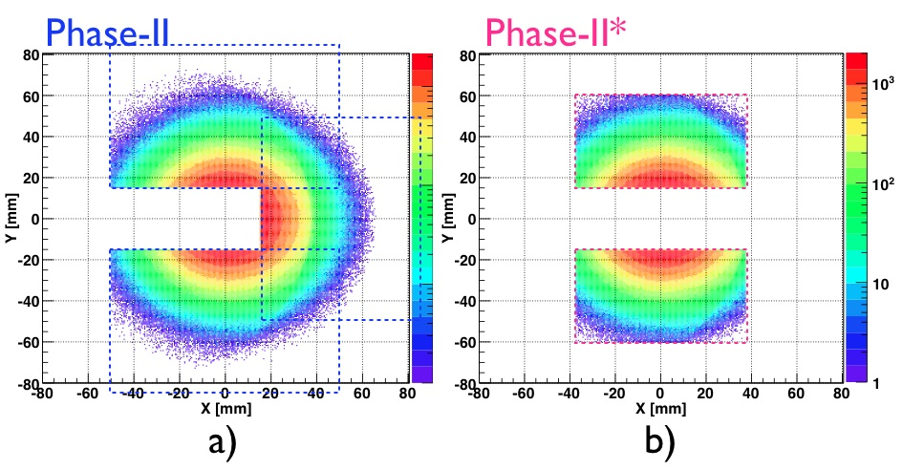

Figure 2 Acceptance of protons from double Pomeron exchange processes in p+p at √s = 500 GeV

as function of *t* for Phase-II (blue) and Phase-II\* (red) configuration. The acceptance for Phase-I

setup is also shown (grey).

Figure 3 Distributions of protons at the upstream RPs for Phase-II (a) and Phase-II\*(b) configurations. The detector coverage is shown with dotted boxes.

**Polarized 3He + p**

It is crucial to identify two spectator protons for selecting process with n+p scattering in 3He+p collisions.

Most of the spectator protons in 3He will be populated in the horizontal/bending plane due to magnetic rigidity changes 3He:p = 3/2:1.

The Phase-II\* configuration without horizontal detector, the acceptance for the two spectator protons is ~10%. **The Phase-II detector setup with horizontal planes increases the acceptance for the two spectator protons to ~92%** as shown in Fig. 4.

Macintosh HD:Users:jhlee:Desktop:he3_acc_compare_at_15m_phase2_phase2a.pdf

Figure 4 Position distributions (Y vs X) at the Roman Pots for the spectator protons from 3He. The Phase-II detector setup is shown as blue boxes and the Phase-II\* setup is shown as red boxes.

\*p process in pp and Ap for AUT /GPD measurements

To identify/separate quasi-real photon and Pomeron processes in exclusive p(A)+p → p(A\*)+ J/* *+p reactions, knowing and covering wide range of momentum transfer *t* for the process is required. Fig. 5 shows two distributions of *t* for \* vertex, which dominates at very small-|*t*| while the |*t*| for the Pomeron vertex is much larger at “typical hadronic size”.

Large increase in acceptance at large-*t* for Phase-II, as shown in Fig. 2, will **significantly increase the yield and kinematic selection of the exclusive p process in p+p and A+p collisions.**

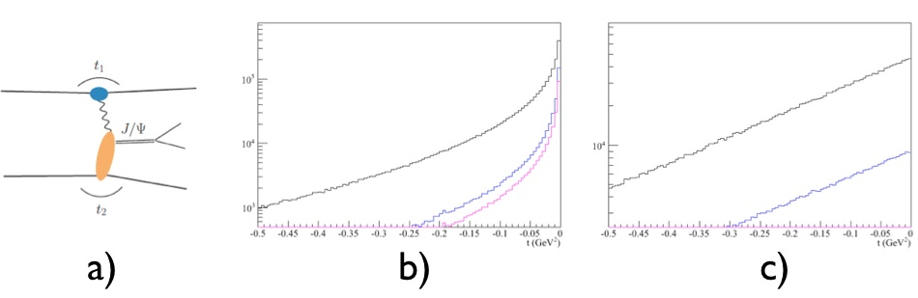

Figure 5 *t*-distributions of the process shown in a). The *t*-distribution for the virtual photon (*t1*) is shown in b) and the *t*-distribution for the Pomeron (*t2*) is in c). Different color lines correspond to acceptance of + - from J/

1. A quote form PAC recommendation in 2011 regarding pp2pp running at STAR, bold emphasis is ours. It clearly stresses a need for a scenario of running “… parasitically without impacting the other goals of RHIC…”

*“Given that RHIC has not yet achieved its main p+p physics goals, the PAC does not think that a week of RHIC operations should at present be dedicated to the pp2pp experiment.* ***The PAC’s viewpoint on this would likely change if the experiment could run with normal beam tunes, that is, parasitically without impacting the other goals at RHIC.*** *We encourage the proponents of the experiment to work toward finding a viable way for achieving this and to present their case again subsequently, including a presentation of the main scientific goals of the experiment.*”

**2. Cost and Effort Estimate of Phase-II\* at STAR**

We are requesting engineering, design and implementation of the Phase-II\* of the Roman Pot upgrade at STAR. This Phase-II\* allows addressing a significant portion of the original Phase-II program.

Since we are proposing to reuse existing Roma Pots, the implementation of Phase-II\* is straightforward and requires minimal resources in terms of design and installation. Installation can be accomplished during the summer of 2014 shut down, to be ready to take data in FY15 run utilizing polarized proton nucleus (p🡹A) and pp collisions.

⇓ RP at 15.2 m

⇓ RP at 17.3 m

Figure 6 Proposed location and layout of Phase-II\* Roman Pots.

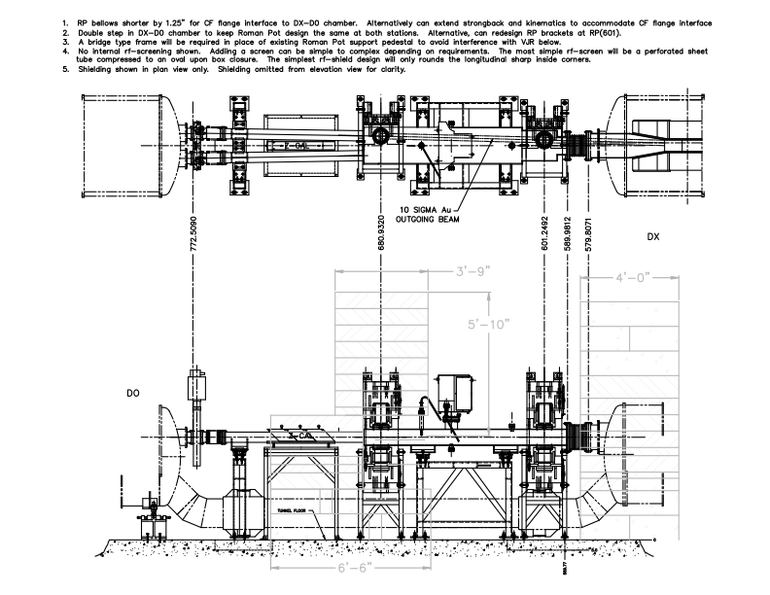

The existing Roman Pots stations will be moved to the locations as indicated in Fig. 6, and described in the previous section. The solution we are proposing is compatible with both pA and pp running. Its new vacuum chamber will be designed to accommodate the horizontal Roman Pots planned for the future full Phase-II.

To install the new vacuum chamber and the Roman Pots, some reconfiguration of the exiting shielding will be required at an approximate cost $85k to help offset the cost for building trades (mostly rigging). We would like to note that reconfiguration of this shielding might be in needed, independent of the Roman Pots Phase-II\*/II vacuum chamber installation, to allow for pA running.

Resources required to implement our plan are shown in Tables below. They are in FY12 dollars and include full burden. A 30% contingency is included for the vacuum portion.

|  |  |  |
| --- | --- | --- |
| **FY 13** | | |
| Task | Time (hrs) | Cost ($) |
|  |  |  |
| Vacuum Designer | 240 | 40,000 |
| Safety review |  |  |
| **TOTAL** |  | **40,000** |
|  |  |  |

|  |  |  |
| --- | --- | --- |
| **FY 14** | | |
|  | Time (hrs) | Cost ($) |
| **Purchases** |  |  |
| Vacuum chambers |  | 125,000 |
| Other parts |  | 65,000 |
| RP related |  | 50,000 |
| Controls related |  | 10,000 |
| **Installation manpower (Summer 2014)** |  |  |
| Trades for RPs and vacuum | 128 | 25,000 |
| Controls trades, cable pulling |  | 5,000 |
| **Total above** |  | **280,000** |
| Shielding Reconfiguration\* |  | 85,000 |
| **TOTAL** |  | **365,000** |
| \* Note shielding reconfiguration may be needed independently as noted in the text |  |  |